**INDEX**

**1. SYNOPSIS**

1.1 PROJECT TITLE………………………………………………………….4

1.2 TECHNICAL KEYWORDS……………………………………………...4

1.3 PROBLEM STATEMENT………………………………………………..4

1.4 ABSTRACT……………………………………………………………….4

1.5 GOALS AND OBJECTIVE……………………………………………... 5

1.6 LITERATURE SURVEY………………………………………………....5

1.7 REQUIREMENT………………………………………………………….5

1.8 PLAN OF PROJECT EXECUTION……………………………………...6

**2. TECHNICAL KEYWORDS**

2.1 AREA OF PROJECT……………………………………………………….8

2.2 TECHNICAL KEYWORDS………………………………………………..8

**3. INTRODUCTION**

3.1 PROJECT IDEA……………………………………………………………..10

3.2 MOTIVATION OF THE PROJECT………………………………………...10

3.3 LITERATURE SURVEY……………………………………………………11

**4. PROBLEM DEFINATION AND SCOPE**

4.1 PROBLEM STATEMENT…………………………………………………13

4.1.1 GOALS AND OBJECTIVES……………………………………………13

4.1.2 STATEMENT OF SCOPE……………………………………………….13

4.2 MAJOR CONSTRAINTS………………………………………………….13

4.3 METHODOLOGIES OF PROBLEM SOLVING………………………… 13

4.4 SCENARIO IN WHICH MODULAR APPROACH USED……………...14

4.5 PLANED OUTCOME………………………………………………………14

4.6 APPLICATIONS…………………………………………………………. ..14

4.7 HARDWARE RESOURCES REQUIRED………………………………. ..14

4.8 SOFTWARE RESOURCES REQUIRED……………………………... ..14

**5. PROJECT PLAN**

5.1 PROJECT ESTIMATES…………………………………………………16

5.1.1 TIME ESTIMATES……………………………………………………16

5.1.2 PROJECT RESOURCES……………………………………………....16

5.2 PROJECT SCHEDULE………………………………………………….16

5.3.1 PROJECT TASK SET………………………………………………….17

**6. SOFTWARE REQUIREMENT**

6.1 USAGE SCENARIO……………………………………………………....19

6.2 FUNCTIONAL MODEL AND DESCRIPTION…………………………20

6.2.1 CLASS DIAGRAM……………………………………………………...20

6.2.2 DATA FLOW DIAGRAM………………………………………………21

6.2.3 ACTIVITY DIAGRAM…………………………………………………22

6.2.4 DEPLOYMENT DIAGRAM……………………………………………23

**7. DESIGN**

7.1 INTRODUCTION………………………………………………………… 25

7.2 ARCHITECTURAL DESIGN…………………………………………… 25

**8. PROJECT IMPLEMENTATION**

8.1 INTRODUCTION………………………………………………………… 27

**9. CONCLUSION**……………………………………………………………………... 29

**10. REFERENCES**…………………………………………………………………… 31

**CHAPTER 1**

**SYNOPSIS**

**1. Synopsis**

**1.1 Project Title**

Solar Power forecast using Machine Learning

**Group ID:** M13

**Team Members:**

1. Aniket
2. Mrigais
3. Dhananjay Jha
4. Harjit Singh

**1.2 Technical Keywords**

* Solar Power
* Machine Learning
* Prediction Model
* Data Analytics
* Algorithms

**1.3 Problem Statement**

* To develop a system for accurately predicting the power forecasting of solar power for PV systems using machine learning for a short period of time.
* The system comprises of machine learning modules which will predict the power generation by solar PV systems by taking into consideration different meteorological and weather related parameters.

**1.4 Abstract**

It discusses the theoretical assumptions and design aspects of developing a Model which will predict the solar power generation beforehand. The project aims at promoting the use of renewable source of energy by developing a model which will accurately predict the solar power generation. Climate change and energy crisis have motivated us to make use of renewable non conventional source of energy. So developing a model to predict the power generation using various Machine Learning Algorithms will be beneficial to both Industries and Residents.

**1.5 Goals and Objectives**

* The main objective is to benchmark different forecasting techniques of solar PV panel energy output. Towards this end, machine learning and statistical techniques can be used to dynamically learn the relationship between different weather conditions and the energy output of PV systems.
* This is being done to optimize the energy structure and improve the performance of a PV system.
* Accurate prediction of PV power output is required to make better generation plans, support the spatial and temporal compensation, and achieve coordinated power control, so that the need for energy storage capacity and operating costs can be reduced.
* Our aim is to investigate the future engineering methodologies, which can be used to increase the overall prediction accuracy.
* We will be using various techniques to train models on solar irradiance data and different meteorological parameters to forecast solar irradiance, and therefore power, for different forecasting horizons in the short-term future.

**1.6 Literature Survey**

Predicting Solar generation from weather forecasts

Authors: N. Sharma, P. Sharma, D. Irwin, and P. Shenoy

1. Deep Learning for Solar Power Forecasting

Authors: Andr´e Gensler, Janosch Henze, Bernhard Sick

1. Short-term Power forecast of Solar PV Systems

Authors: Mayukh Samanta, Bharath K. Srikanth, J B Yerrapragada

**1.7 Requirements**

**Software Requirements**

* + Anaconda 5.2
  + Python 3
  + OS- Windows7/MAC

**Hardware Requirements**

* + RAM 8GB
  + Processor i3 or Higher
  + Hard Disk 500GB

**1.8 Plan Of Execution**

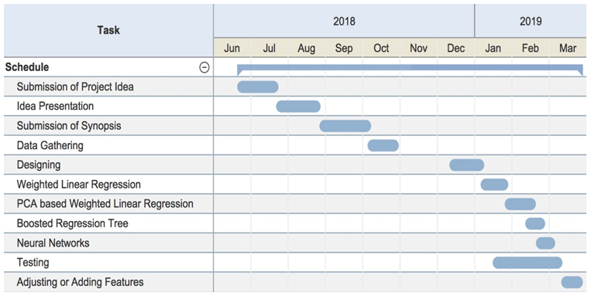

**CHAPTER 2**

**TECHNICAL KEYWORDS**

**2. Technical Keywords**

**2.1 Area Of Project**

Machine Learning based application.

**2.2 Technical Keywords**

* Solar power
* Machine Learning
* Algorithms
* Prediction Model

**CHAPTER 3**

**INTRODUCTION**

**3. Introduction**

**3.1 Project Idea**

Climate change and energy crisis have led us to use renewable energy use and Solar Energy is one of the most appropriate option for use. It is renewable as well as non conventional source of energy and available in abundance. Power generated using Solar PV Panels depends on many external factors namely weather and meteorological factors. Factors such as Wind, Cloud and Rain also affect the rate of Power Generated. We will work on developing a model which will have high level of accuracy in predicting solar power. To do so we will compare various Machine Learning Algorithms and find the most accurate.

The Dataset will be divided into Training and Test Data after pre-processing and scaling and various Machine Learning Algorithms will be applied to find out the most accurate of them. The most suitable one will be applied in the model to predict the power.

The dataset used in this work is historical weather data from Amherst, MA, and is maintained by the University of Massachusetts, Amherst – Computer Science Weather Station.

**3.2 Motivation Of The Project**

Roof-top mounted solar photovoltaic (PV) systems are becoming an increasingly popular means of incorporating clean energy into the consumption profile of its users. It is one of the most efficient renewable source of energy which can be used over non renewable sources of energy as Fossil Fuels. There are certain influencing factors which promote the use of Solar Energy such as environment friendly and safer than traditional electricity current. The motivation behind taking up this project was to implement a model which would help people manage the energy resources in an efficient and economic way. This model can help the user to pre-plan and use the power according to the prediction made by different machine learning and statistical techniques and avoid any sorts of loss due to sudden weather changes which are not in their control. Application of this model incurs low cost for installation (economical), safer and comparatively more available than other energy resources. Electric utilities often allow the inter-connection of such systems to the grid, compensating system owners for electricity production. As the systems grow in number and their contribution to the overall load profile becomes increasingly significant, it becomes imperative for utilities to accurately account for them while planning and forecasting generation.

**3.3 Literature Survey**

A similar study has already been done previously. The comparative study is given below. The Advantages and Limitations of the Papers are discussed which will be overcome in our study.

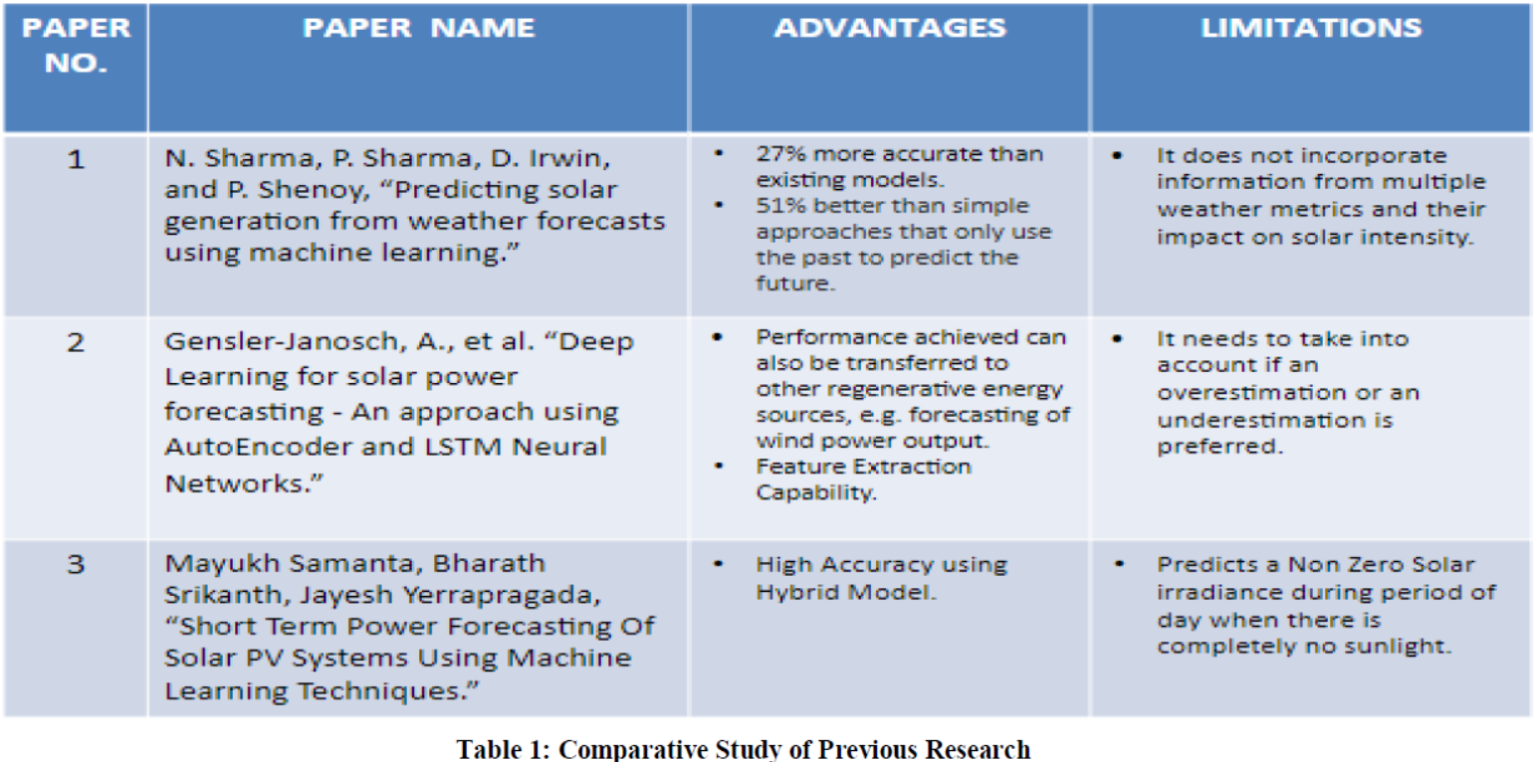

**CHAPTER 4**

**PROBLEM DEFINITION AND SCOPE**

**4. Problem Definition and Scope**

**4.1 Problem Statement**

* To develop a system for accurately predicting the power forecasting of solar power for PV systems using machine learning for a short period of time.

**4.1.1 Goals and objectives**

* The main objective is to benchmark different forecasting techniques of solar PV panel energy output. Towards this end, machine learning and statistical techniques can be used to dynamically learn the relationship between different weather conditions and the energy output of PV systems.
* This is being done to optimize the energy structure and improve the performance of a PV system.
* Accurate prediction of PV power output is required to make better generation plans, support the spatial and temporal compensation, and achieve coordinated power control, so that the need for energy storage capacity and operating costs can be reduced.
* Our aim is to investigate the future engineering methodologies, which can be used to increase the overall prediction accuracy.
* We will be using various techniques to train models on solar irradiance data and different meteorological parameters to forecast solar irradiance, and therefore power, for different forecasting horizons in the short-term future.

**4.1.2 Statement of scope**

To offer the near future weather conditions to the user so that they can manage the power that is harnessed by the sunlight.

**4.2 Major Constraints**

The user should have a Smartphone device which high speed internet is accessible.

**4.3 Methodology of problem solving and efficiency issues**

Step1: User will enter the name of the city whose weather data he/she will be using for solar power forecasting.

Step2: API will fetch the weather data from open source weather forecast website.

Step3: The weather data will be fed to the machine learning algorithms.

Step4: The algorithms will then use this data to forecast the solar power.

Step5: The prediction will be displayed to the user through graphical representation.

**4.4 Scenarios in which modular approach is used**

Project is a top down approach which uses modular approach. City name is given as the input to the application module and output of this module is shown as the forecasting through a graphical means of representation.

**4.5 Planned Outcome**

Develop an application which would help people to know the near future solar power through most accurate predictions done by the machine learning algorithms used in the application.

**4.6 Application**

* Solar power prediction
* Power management

**4.7 Hardware Resources Required**

|  |  |  |  |
| --- | --- | --- | --- |
| Sr.No | Parameters | Recommended requirements | Justification |
| 1 | Android  Mobile Phone | Kitkat version | Must not be  less than this |
| 2 | CPU Speed | 1.2 GHz | Speed must  be equal or  more than this |
| 3 | RAM | 1 GB | Must not be  less than this |

* 1. **Software Resources Required**
* Anaconda 5.2
* Python 3.6
* JSP Java
* Apache Tomcat
* Open source API key of *openweathermap.org*

**CHAPTER 5**

**PROJECT PLAN**

**5. Project Plan**

**5.1 Project Estimates**

**5.1.1 Time Estimates**

Time Estimate is for about 9 months approximately.

|  |  |  |
| --- | --- | --- |
| Sr. No. | Estimates | Time Taken |
| 1 | Literature Survey | 2 |
| 2 | Design | 1 |
| 3 | Presentation | 1 |
| 4 | Coding | 3 |
| 5 | Testing | 1 |
| 6 | Reporting | 1 |
| 7 | TOTAL | 9 |

**5.1.2 PROJECT RESOURCES**

Project resources required are Smartphone or PCs/laptops (internet connectivity) and Anaconda (For running python codes of ML algorithms).

* 1. **RISK MANAGEMENT W.R.T. NP HARD ANALYSIS**
* P-class problem: P is set of all decision problems which can be solved in polynomial time by a deterministic. Since it can be solved in polynomial time, it can be verified in polynomial time. Therefore P is a subset of NP.
* NP-class problem:” NP” means “we can solve it in polynomial time if we can break the normal rules of step-by-step computing”.
* NP-Hard problem: A problem is NP-hard if an algorithm for solving it can be translated into one for solving any NP-problem (nondeterministic polynomial time) problem. NP-hard therefore means “at least as hard as any NP-problem,” although it might, in fact, be harder.
* NP-Complete problem: Since this amazing” computer can also do anything a normal computer can, we know that” P” problems are also in” NP”. So, the easy problems are in” P” (and” NP”), but the really hard ones are only in” NP”, and they are called” NP-complete”. It is like saying there are things that People can do (” P”), there are things that Super People can do (” SP”), and there are things *only* Super People can do (” SP-complete” ).
* Our project, Power Forecast of Solar Panels Using Machine Learning Techniques can be realized in P(Polynomial Time)

**5.3 Project Schedule**

**5.3.1 Project Task Set**

Major Tasks in the Project stages are:

1: Research about solar power forecasting.

2: Research about selected topic.

3: Literature survey.

4: Deciding the flow of project plan.

5: Determine the Requirement.

6: Dividing the task.

7: Formulate the code.

8: Testing.

9: Project Complete Demonstration.

**5.3.2 Timeline Chart**

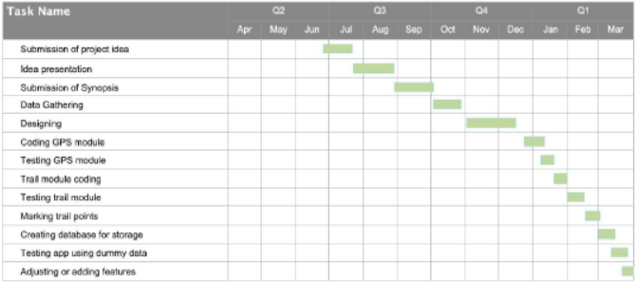

**CHAPTER 6**

**SOFTWARE REQUIREMENT**

**6. Software Requirement**

**6.1 Use Case Scenario**

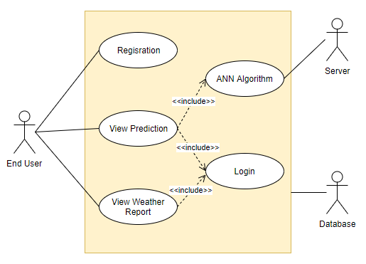

The use-case diagram clearly depicts three actors in the system. Two human actors and one non human actor. The two human actors are the Admin and the End user.The Admin feeds the dataset to the machine learning which then prepares, cleans, and analyzes the data. All this data preprocessing techniques include data correction, correction of errors and application of neural network algorithms.

Then the use-case ML Model forecasts the solar power to the use-case End User. This forecast is provided to the use-case End User through graphical representation.

**6.2 Functional Model and Description**

**6.2.1 Class Diagram**

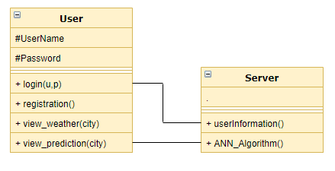

**6.2.2 Data Flow Diagram**

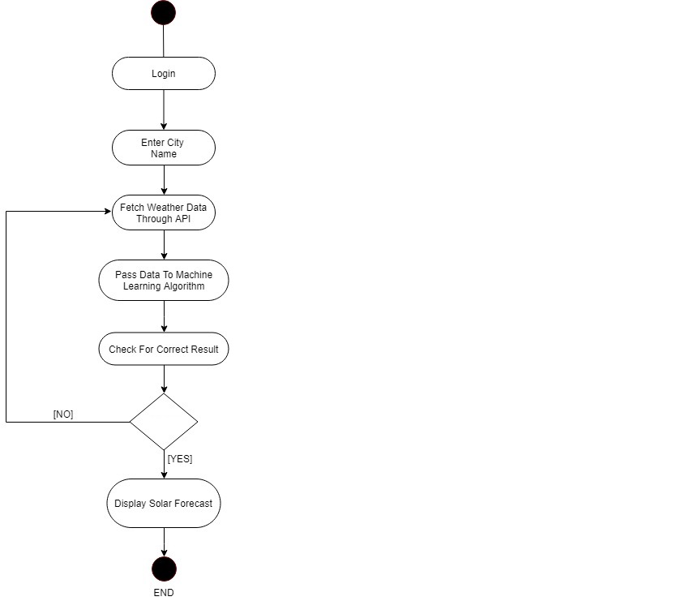

**6.2.3 Activity Diagram**

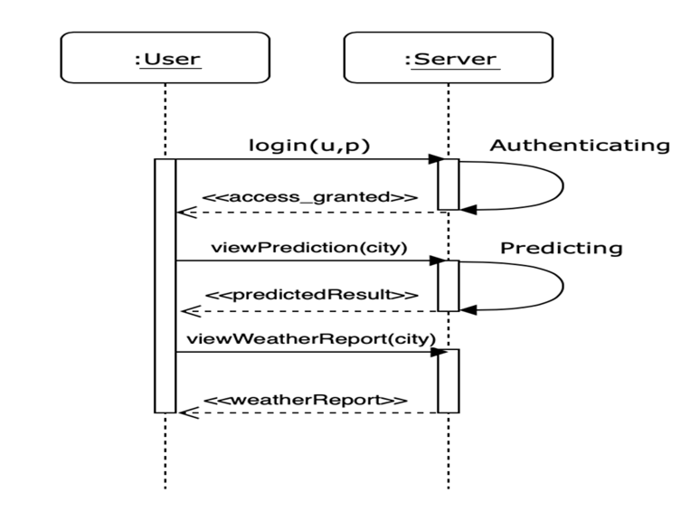

**6.2.4 Deployment Diagram**

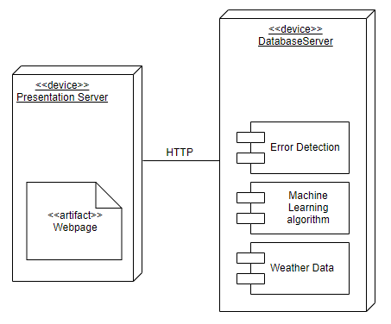

**CHAPTER 7**

**DESIGN**

**7. Design**

**7.1 Introduction**

This topic specifies the interpreted and expected implementation of the project that

should facilitate efficiency and responsiveness of the application to the user.

**7.2 Architectural Design**

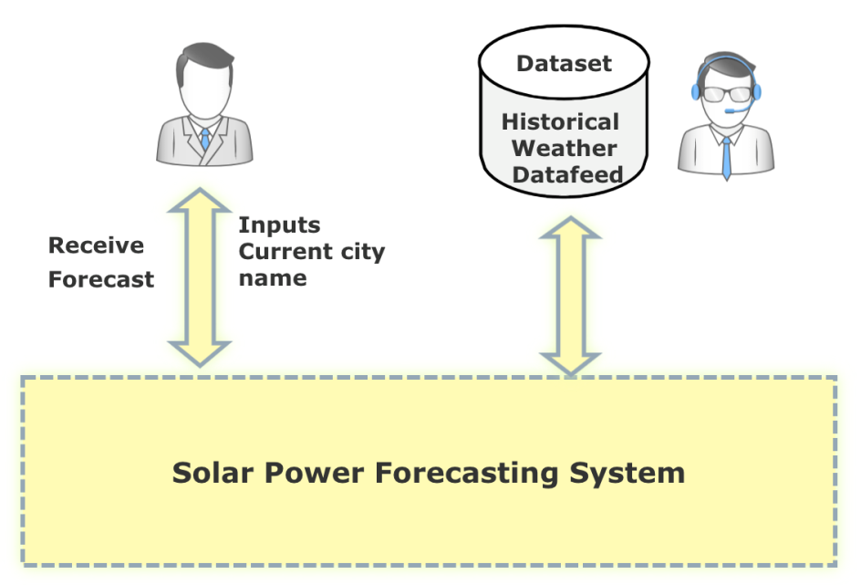

Admin

End User

Fig 7.1 : System Architecture

The user inputs the name of the city he wants weather details of in the solar power forecasting system. This system includes the machine learning algorithms that will be used for forecasting. When the API fetches the data from historic weather data, this data is fed to the solar power forecasting system .Now the user receives the forecast from the solar power forecasting system in a graphical form.

**CHAPTER 8**

**PROJECT IMPLEMENTATION**

**8. Project Implementation**

* 1. **Introduction**
* When a person is unfamiliar of the weather condition of a particular area and wants to know and manage the solar power they’ll be having for upcoming days, it is important for them to have the knowledge of solar power in near future so that they can keep a track of power consumption and manage it. This forecast enhances the way a person will manage the solar power usage in their household while keeping a track of the weather condition for upcoming days. Roof-top mounted solar photovoltaic (PV) systems are becoming an increasingly popular means of incorporating clean energy into the consumption profile of its users. It is one of the most efficient renewable sources of energy which can be used over non renewable sources of energy like Fossil Fuels.
* Initially the screen will show the user information and by entering the city name, the API key will fetch the weather data from ***openweathermap.org.***This data will be fed to the ML algorithm which in return will forecast the solar power that will be generated in upcoming days.

**CHAPTER 9**

**CONCLUSION**

**9. Conclusion**

This model will help user predict the Solar Power Generation. It will guide the user through unfamiliar situation which can occur so that he could save power prior itself. It will also help in promoting use of renewable source of energy.

**REFERENCES**

**References**

[1] N. Sharma, P. Sharma, D. Irwin, and P. Shenoy, “Predicting solar generation from weather forecasts using machine learning,” in Smart Grid Communications (SmartGridComm), 2011 IEEE International Conference on, pp. 528–533, IEEE, 2011.

[2] Gensler-Janosch, A., et al. “Deep Learning for solar power forecasting — An approach using AutoEncoder and LSTM Neural Networks.” 2016 IEEE International Conference on Systems, Man, and Cybernetics (SMC), 2016

[3] Mayukh Samanta, Bharath Srikanth, Jayesh Yerrapragada, “Short Term Power Forecasting Of Solar PV Systems Using Machine Learning Techniques.”

[4]http://s35695.mini.alsoenergy.com/Dashboard/2a5669735065572f4a42454b772b714d3d

[5] https://machinelearningmastery.com/use-keras-deep-learning-models-scikit-learn-python/